**PRACTICAL NO:-6**

**a. Create a web application for inserting and deleting records from a database.**

First we have to create a .mdf file to connect to the database.

As follow:-

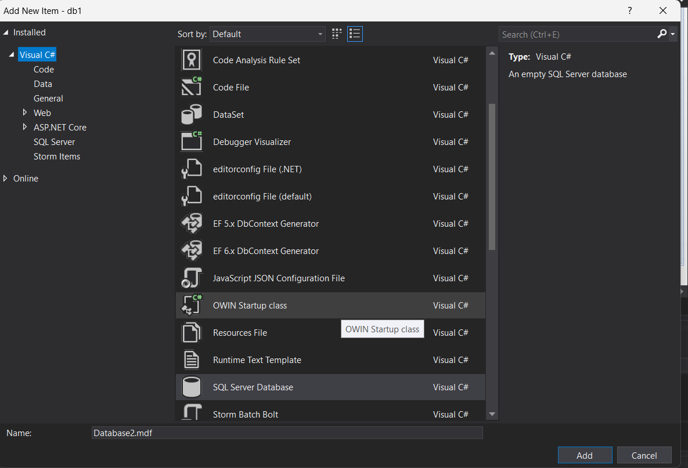

Now in server explorer refresh in data connection to the connectionstring.

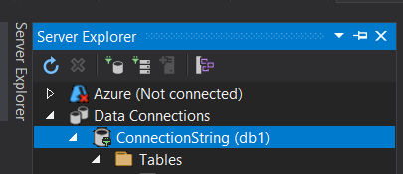

Now write a query in tables we just right click it write new query for table creation.

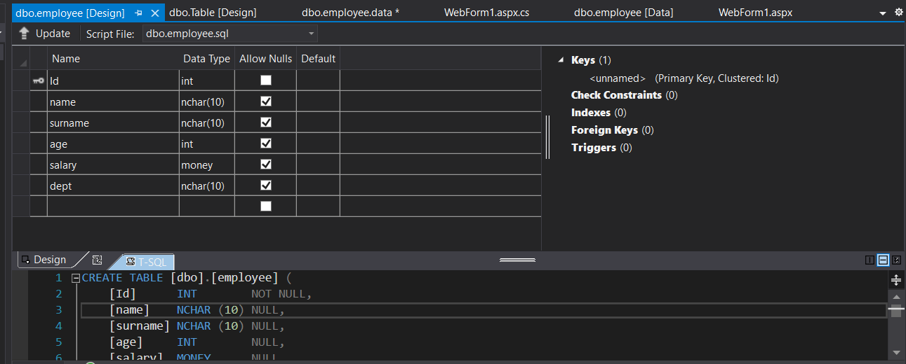

Now choose the below property of show data to insert into some values:-

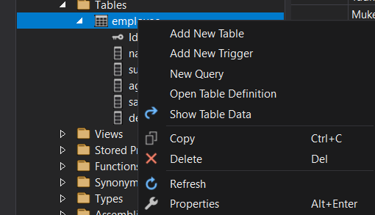

Now I have added grid view to display data:-

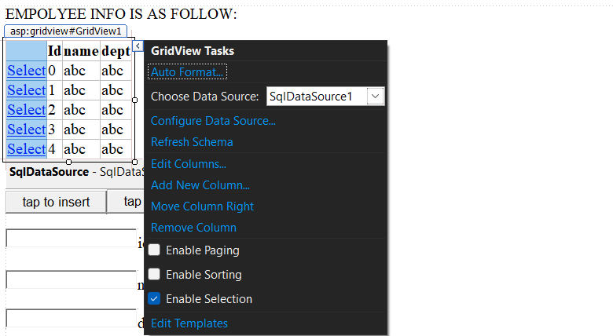

Now chooses the data source here choose data source option to add data source here.

And also enable the option of enable selection option so that the selected row can be accessed to choose data here.

Now have written code so that insertion deletion and also one can access full data of selected rows data from here:-

**CODE:-**

using System;

using System.Collections.Generic;

using System.Linq;

using System.Web;

using System.Web.UI;

using System.Web.UI.WebControls;

using System.Data.SqlClient;

using System.Data;

namespace db1

{

public partial class WebForm1 : System.Web.UI.Page

{

protected void Page_Load(object sender, EventArgs e)

{

TextBox1.Visible = false;

TextBox2.Visible = false;

TextBox3.Visible = false;

Label1.Visible = false;

Label2.Visible = false;

Label3.Visible = false;

Button2.Visible = false;

TextBox4.Visible = false;

Button4.Visible = false;

}

protected void GridView1_SelectedIndexChanged(object sender, EventArgs e)

{

GridViewRow row_data = GridView1.SelectedRow;

String txt = row_data.Cells[1].Text;

//Response.Write(txt);

int a = Convert.ToInt32(txt);

SqlConnection cn = new SqlConnection(@"Data Source=(LocalDB)\MSSQLLocalDB;AttachDbFilename=C:\Users\karan\source\repos\db1\db1\App_Data\Database1.mdf;Integrated Security=True");

SqlCommand cmd = new SqlCommand("select * from employee where id='" +a + "' ",cn);

cn.Open();

SqlDataReader dr = cmd.ExecuteReader();

DetailsView1.DataSource = dr;

DetailsView1.DataBind();

cn.Close();

}

protected void TextBox2_TextChanged(object sender, EventArgs e)

{

}

protected void Button1_Click(object sender, EventArgs e)

{

TextBox1.Visible = true;

TextBox2.Visible = true;

TextBox3.Visible = true;

Label1.Visible = true;

Label2.Visible = true;

Label3.Visible = true;

Button2.Visible = true;

}

protected void Button2_Click(object sender, EventArgs e)

{

string a = TextBox2.Text, b = TextBox1.Text, c = TextBox3.Text;

int a1 = Convert.ToInt32(a);

SqlConnection cn = new SqlConnection(@"Data Source=(LocalDB)\MSSQLLocalDB;AttachDbFilename=C:\Users\karan\source\repos\db1\db1\App_Data\Database1.mdf;Integrated Security=True");

SqlCommand cmd = new SqlCommand(

"insert into employee(id,name,dept) values ( '"+a1+"' , '"+b+"', '"+c+"' );",cn

); ;

cn.Open();

cmd.ExecuteNonQuery();

GridView1.DataBind();

cn.Close();

Label4.Text="Data inserted successfully.";

}

protected void Button3_Click(object sender, EventArgs e)

{

TextBox4.Visible = true;

Button4.Visible = true;

Label1.Visible = true;

}

protected void Button4_Click(object sender, EventArgs e)

{

string s = TextBox4.Text;

int a = Convert.ToInt32(s);

SqlConnection cn = new SqlConnection(@"Data Source=(LocalDB)\MSSQLLocalDB;AttachDbFilename=C:\Users\karan\source\repos\db1\db1\App_Data\Database1.mdf;Integrated Security=True");

SqlCommand cmd = new SqlCommand("delete from employee where id='" + a + "' ", cn);

cn.Open();

cmd.ExecuteNonQuery();

GridView1.DataBind();

cn.Close();

Label4.Text = "data deleted successfully";

}

protected void SqlDataSource1_Selecting(object sender, SqlDataSourceSelectingEventArgs e)

{

}

}

}

HERE I first choose row first so that the data fully is visible in DetailView.

As follow:-

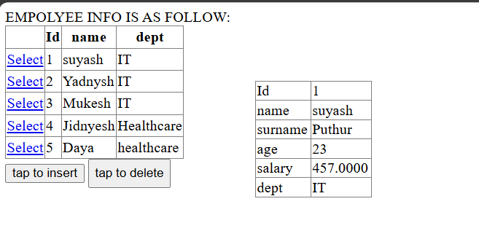

NOW insert data into table:-

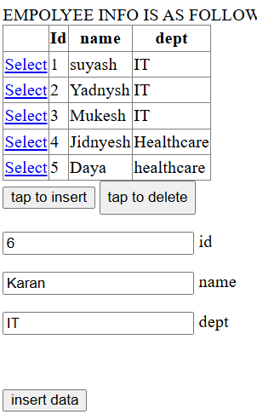

Inserted data:-

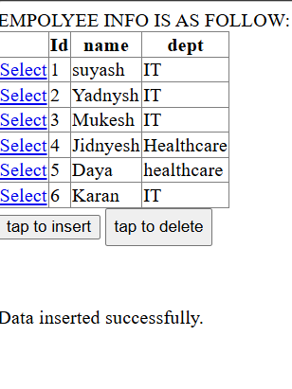

Now deleting data:-

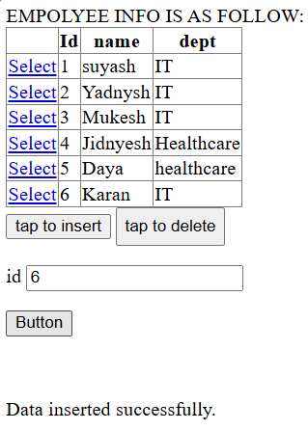

On button click:-

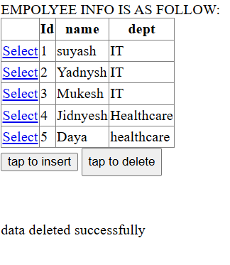

Disconnected architecture:-

Here the data source right now is not defined It is defined through coding.

**CODE:-**

using System;

using System.Collections.Generic;

using System.Linq;

using System.Web;

using System.Web.UI;

using System.Web.UI.WebControls;

using System.Data;

using System.Data.SqlClient;

namespace db1

{

public partial class disconnected_ : System.Web.UI.Page

{

protected void Page_Load(object sender, EventArgs e)

{

SqlConnection cn = new SqlConnection(@"Data Source=(LocalDB)\MSSQLLocalDB;AttachDbFilename=C:\Users\karan\source\repos\db1\db1\App_Data\Database1.mdf;Integrated Security=True");

DataSet ds;

SqlDataAdapter da;

da = new SqlDataAdapter("Select * from employee",cn);

ds = new DataSet();

da.Fill(ds); // da can also use for multiple data adapter just haver to mention name here of them......

GridView1.DataSource = ds;

GridView1.DataBind();

Control[] contr = { Label1, Label2, Label3, TextBox1, TextBox2, TextBox3 ,Button2};

foreach (Control c in contr)

{

c.Visible = false;

}

}

protected void GridView1_SelectedIndexChanged(object sender, EventArgs e)

{

}

protected void Button2_Click(object sender, EventArgs e)

{

SqlConnection cn = new SqlConnection( @"Data Source=(LocalDB)\MSSQLLocalDB;AttachDbFilename=C:\Users\karan\source\repos\db1\db1\App_Data\Database1.mdf;Integrated Security=True");

int a1 = Convert.ToInt32(TextBox3.Text);

string b = TextBox1.Text, c = TextBox2.Text;

SqlCommand cmd = new SqlCommand(

"insert into employee(id,name,dept) values ( '" + a1 + "' , '" + b + "', '" + c + "' );", cn

);

SqlDataAdapter da = new SqlDataAdapter(cmd);

DataTable dt = new DataTable();

da.Fill(dt);

Label4.Text = "Data inserted successfully!";

GridView1.DataSource = dt;

GridView1.DataBind();

}

protected void Button1_Click(object sender, EventArgs e)

{

Control[] contr = { Label1, Label2, Label3, TextBox1, TextBox2, TextBox3 ,Button2};

foreach (Control c in contr)

{

c.Visible = true;

}

}

}

}

